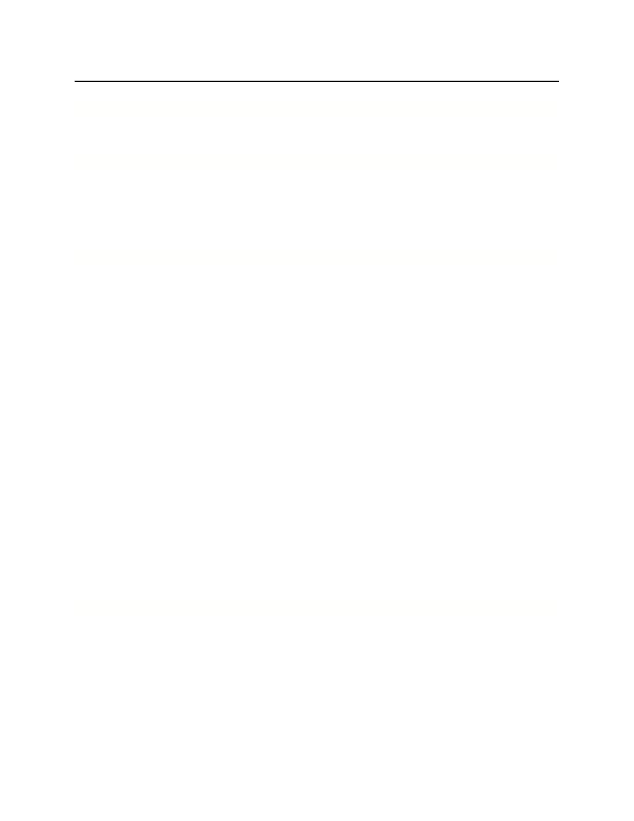
RITA KIEN
OBJECTIVE
Teaching role where experience inelementary and special educationwill make a contribution.
PROFILE/CERTIFICATION
• Strong background in elementary education (six years of experience) and special education (one year of
experience teaching exceptional students, with undergraduate training).
• Experienced creating effective curricula, integrated lessons and parentstaff relations.
• Elementary Education: New Jersey Provisional (pending); New York Provisional Certificate (N6).
• Special Education: New York State Provisional Certificate (K12).
TEACHING EXPERIENCE
Second Grade Teacher,Townsville Day School, Townsville, NJ
2008 to Present
Provide comprehensive lesson planning, teaching and evaluation. Manage Assistant Teacher.
• Developed entire curriculum, integrating Math, Language Arts, Readers and Writers Workshops, Science, Social
Studies and Internet/Technology. Supervise entrance examinations.
• Maintain proactive relations and regular contact with parents. Teach gifted student and modify curriculum
accordingly. Write monthly newsletters featuring student contributions.
• Developed book club to effectively encourage reading at home. Twice served as representative at open house
events, addressing parents on behalf of school.
• Volunteered to organize and serve as chaperone for afterschool skiing program.
• Supervised student efforts to stage two plays on science topics, integrating music and performed before entire
school. Also supervised academic decathlon.
Kindergarten Teacher,Saint Peter's School, Townsville, NJ
2007 to 2008
Developed curriculum and lesson plans to address needs of gifted students and those with learning disabilities. Also
taught Gifted Reading Program for grade 4 students.
• Developed curriculum and lesson plans to address needs of gifted students and those with learning disabilities.
Also taught Gifted Reading Program for grade 4 students.
• Volunteered to serve as Head Advisor for Student Council, working with students in grades 48.
• As Second Grade Teacher (19961997), developed and implemented lesson plans in Math, Reading and Writing.
For outstanding efforts and results with students/parents, chosen for Kindergarten role.
Special Education TeacherR, oosevelt Child Center, Upstate, NY
2005 to 2006
Planned and led classes for economically disadvantaged preschoolers with severe learning disabilities, including
Down Syndrome, autism, behavioral disorders and mental retardation
• Developed entire curriculum, including social and communications skills. Frequently integrated music.
• Consulted with parents regularly, working with Spanish interpreter. Organized fundraising efforts.
EDUCATION/PROFESSIONAL DEVELOPMENT
• Master of Science: Early Childhood Education, Fordham University, Tarrytown, NY (2009).
• Bachelor of Science: Elementary Education/Special Education, St. Thomas Aquinas College, Sparkhill, NY
(2005). Completed semester abroad in Ambleside, England (2004).
• Reading and Writing Project (Lucy McCormick Calkins), Columbia Univ., New York, NY (2010).
• Technology, Spelling and Literacy Workshops: Townsville Day School (2010).

